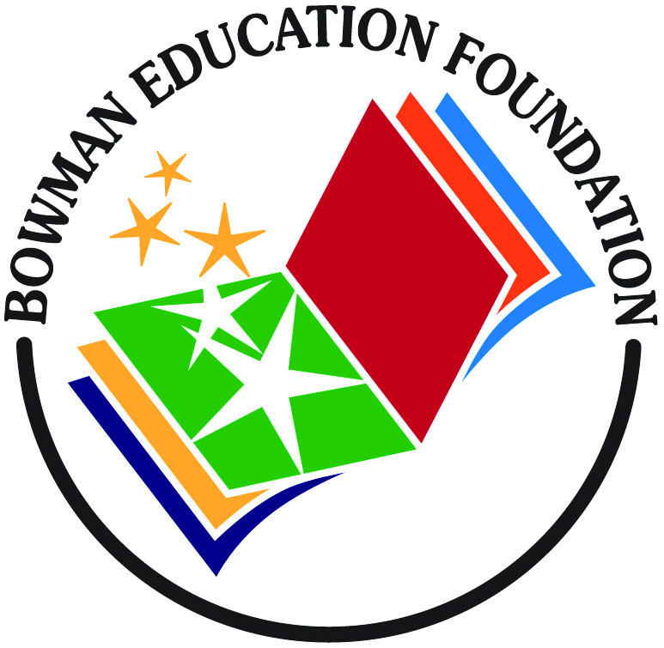 |  | Minutes  Bowman Education Foundation -- Board Meeting  June 24, 2015 @ 5:30pm, Bowman Office
In attendance: Irish Chapman, Chad Bender, David Slane, Kelly Graham, Nicole Spencer, Jim Levy, Chris Barr
Called to order: 5:40 pm

- OLD BUSINESS:

- Approved April 16, 2015 Meeting Minutes: moved by Chris Barr, seconded by Chad Bender to approve April 16, 2015 Meeting Minutes. All ayes vote.
- Treasurer’s Report (Chad): Revenue of $78.00 from Amazon Smile and United Way. Expense for $128.90 for music instruments. Reported net funds of $13,282.43 + paypal $241.54= $13,523.97
- Correspondence-Board: received thank you card from Mrs. Muselie
- Account info: Nicole has Facebook access and updated pictures, transferred Google voice to Nicole's cell phone. Kelly G. to get in contact with Ian to follow up on request from Janice: “My husband's server hosts the DNS links to the website currently, but we'd like to hand this over to someone else …. who is network-saavy. Bob also hosts the mail accounts, which need to find a new home too. Whoever you find, they can contact my husband (bob@zis.com) and he'll give them all the technical details they need. You can probably do all this with NetworkSolutions (will incur some minimal costs).”
- Communications/Coordination
  - Need teacher/staff liaison to BEF to replace Cain; Kelly will assist when BEF direction 2015-16 is clear.
- Annual Insurance renewal: Kelly to email and follow up with Shelly to cover BEF under SIG, the schools insurance group.
- Annual State 501c3 Tax and Corporation Filing- filed
  - Electronic federal filing; waiting for a notice in mail that it hasn't been filed (no penalty). Have to file within three years or lose 501C status.

II. NEW BUSINESS:

- Charting a Course Forward for the BEF
- Discussed the need for purpose, mission etc. to get funds/grants etc. - Summary is we fund any request that is brought to the foundation and is approved by its members.
  - Sports uniforms was suggested by Kelly and later said by Irish that Flyers may pay for this
  - Wells Fargo – to submit for grant, have prepared and submitted by end of January
  - Kelly to provide few bullets of what we can focus our efforts towards next year,-- to use to gain support from parents and community
- Back to school night – should have a table and recruit members. Use Target, Amazon Smile, ebay and other types of fund-raising (Jim proposed a mobile app coupon offering like the coupon books – cost $75 and $35 goes to BEF) BEF to advertise these easy ways to give. Create a flyer with all the options.
- Promotion – letter will be in the student packets, need flyer for back to school night, our meetings are calendared with Julia for communications:
        - Aug- 27
        - Sept 17
        - Oct 15
        - Nov 19
        - Dec 17
        - Jan 21
        - February 25
        - March 17
        - April 21
        - May 26
B. Octoberfest will be held at Whincester on 10/2
  - Meet in Aug. to divide tasks: Food (Kelly will ask around for food), Beer, music, tickets, silent auction, promotion
    - $30 ticket, $15 for staff
    - Class donations – each class made scarecrow, build a basket, other idea
- Next meeting is July 30, 5:30 - first hour with PTO (Kelly to ask Stephanie Labreque to join), second hour on Octoberfest.
D. Chad Bender's term for Treasurer during the 2014-2015 school year is over and he has resigned. Chris Barr nominated for Treasurer, Irish second, all approved. Thank you Chad for your service and Chris, we appreciate you taking and look forward to working with you in this role.

